Practices for Lesson 14: Siebel Logs and Troubleshooting

Practices for Lesson 4

Overview

In these practices, you will explore the Siebel Enterprise, Servers, Component Groups, and Components logs.

Practices 14-1: Explore the Siebel Enterprise Logs

**Overview**   
In this practice, you will look into session and task logs for Siebel enterprise.

Assumptions

You should have completed the Practices of Lesson 2.

Tasks

1. Login as Siebel apps URL – 4430/Siebel/sales/enu

Login as SADMIN user.

1. Navigate to the **Site Map.** Click **Administration – Server management**. This screen allows you to see the current state of your servers. Under **Servers, click Component Groups.**

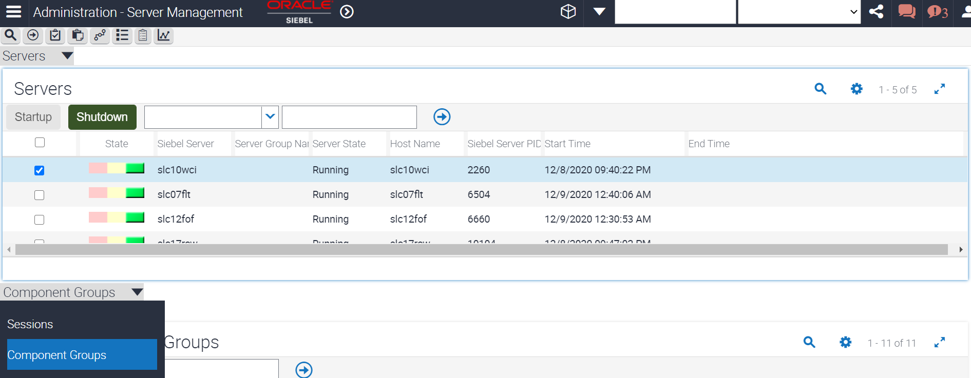

1. Check that you have one Siebel Server listed. Verify the Siebel Server, this is the name of your Siebel Server.
2. In the second level, the currently enabled component groups are displayed along with their state. The Component Logs are here.

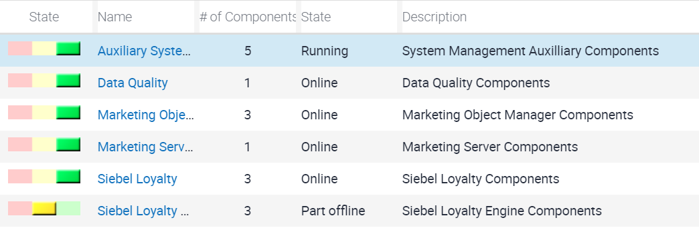

1. Exploring Sessions
2. Click **Session (Server Component Groups)** applet, in the view tabs, click **Sessions.**

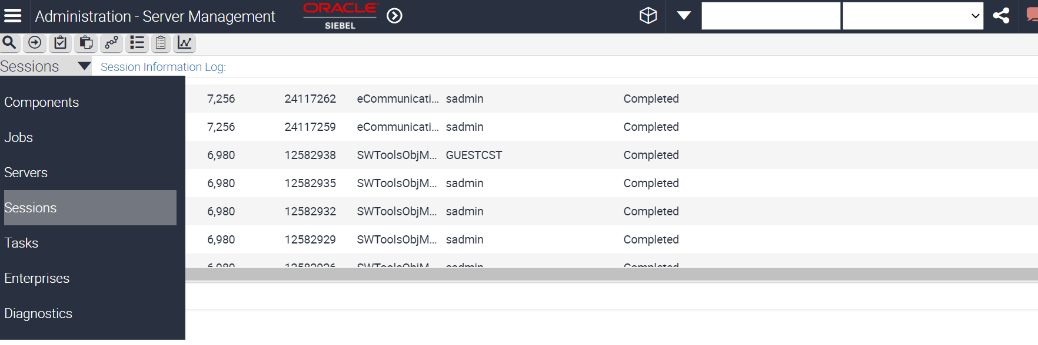

1. At the top of the list applet, verify that you see a session **with Component = ServerMgr.** That represents the server manager screens you are currently viewing.
2. In the list applet, verify that you see a session with **Component = SCCObjMgr_enu,** OM Login = SADMIN, and State = Running. That represents you are currently logged in to the application.

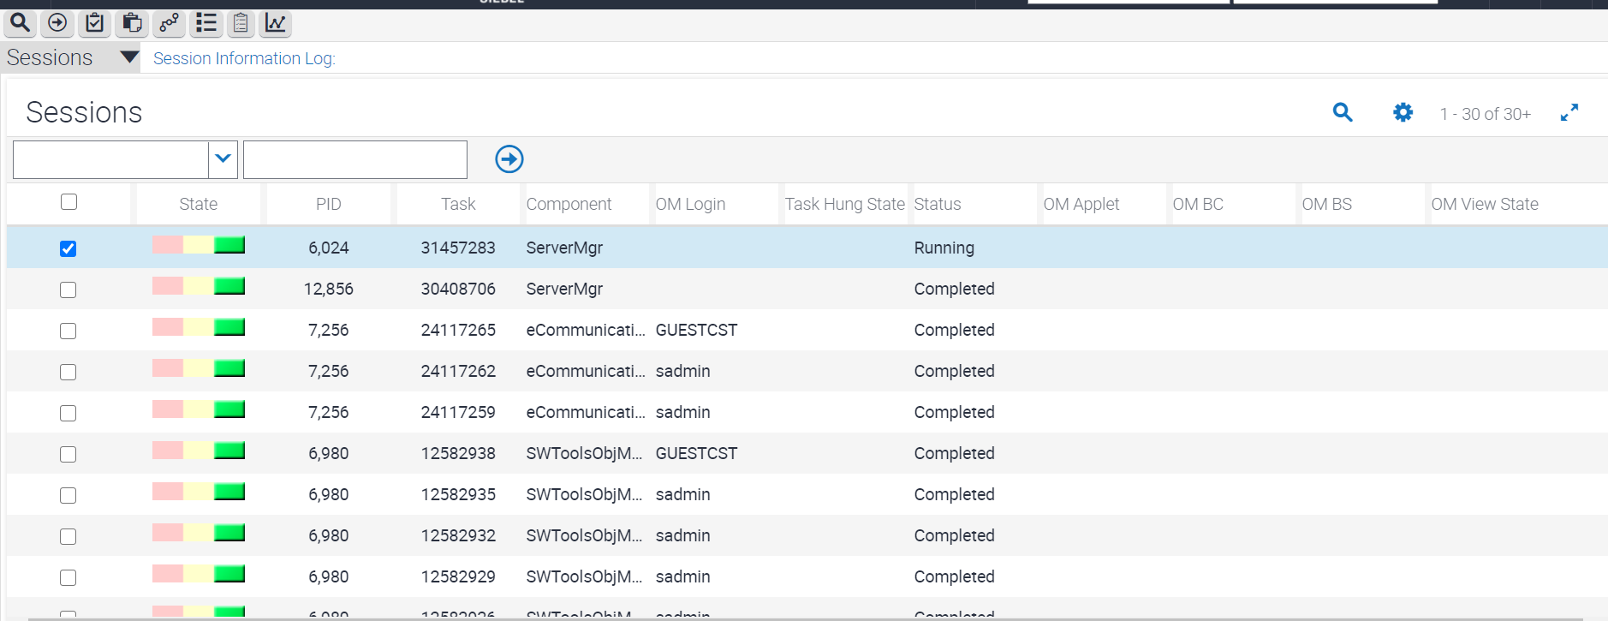

1. Explore the Siebel Enterprise.
2. In the link bar (at the top), click **Enterprises.**

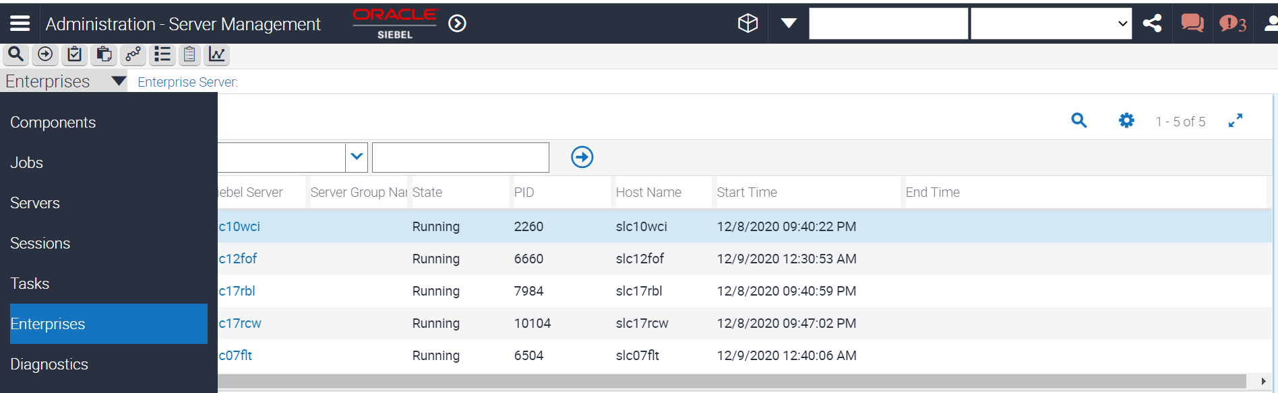

1. Verify that the top applet displays the Enterprise Server. This is the name of your Siebel enterprise.
2. Check that the middle applet displays the Siebel Servers and the bottom applet, displays components assigned to the selected server. This is an alternate way to view the component information.
3. Enable a component
4. Navigate **to Site Map.**
5. Click **Administration - Server Configuration**. This view allows you to modify settings.
6. Click **Enterprise Explorer**. This displays an explorer view  
   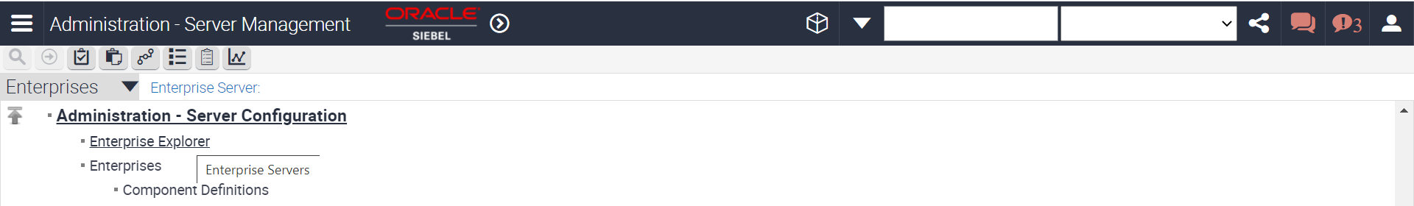
7. In the left pane, expand **the server**.
8. In the left pane, expand **Component Groups.**
9. In the right pane in the list applet, notice that the Name as well as the Alias for the component group is displayed.
10. Query for the record with **Alias = Sales.**
11. Verify that the **Enable state = Enabled**.
12. This means that the component is enabled for the enterprise and available to the Siebel Servers to run.
13. In the link bar, click **Servers.**

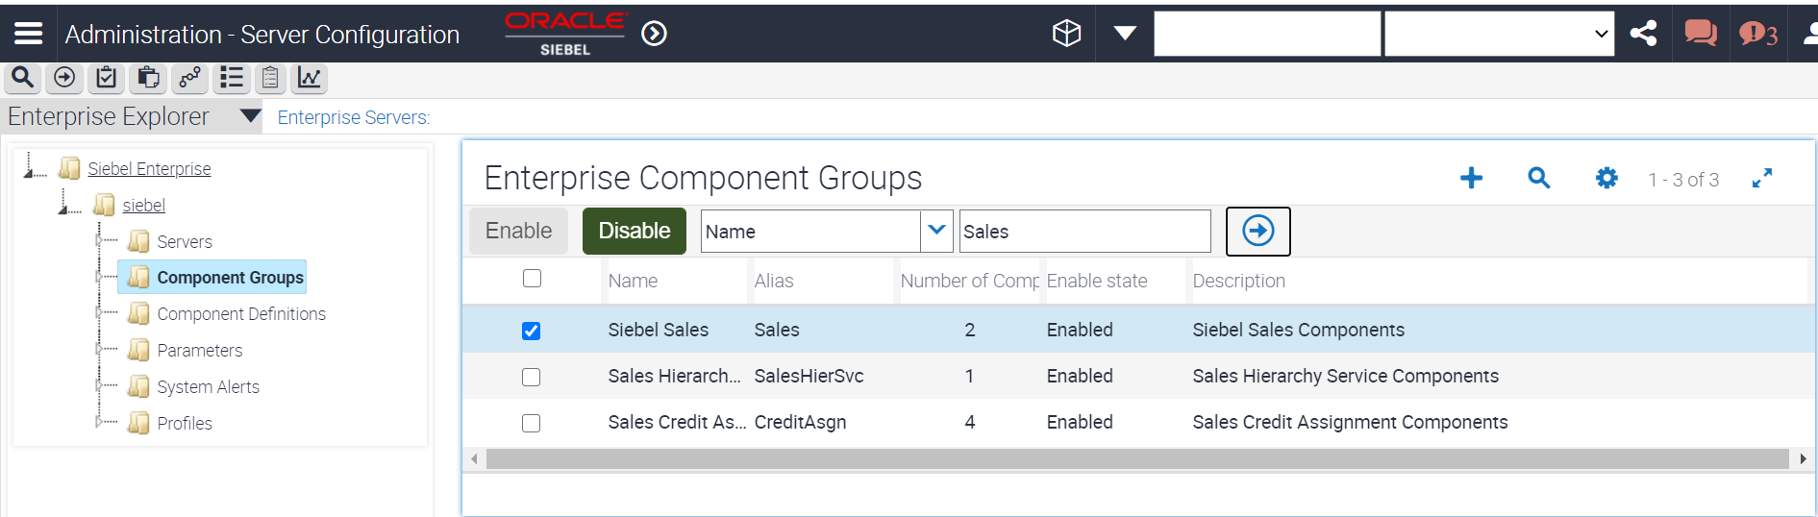

1. Disable a component group
2. In the view tabs at the top, select **Enterprises.**
3. In the Enterprise Component Groups applet, select the record with **Alias = HandheldSyncSIS.**

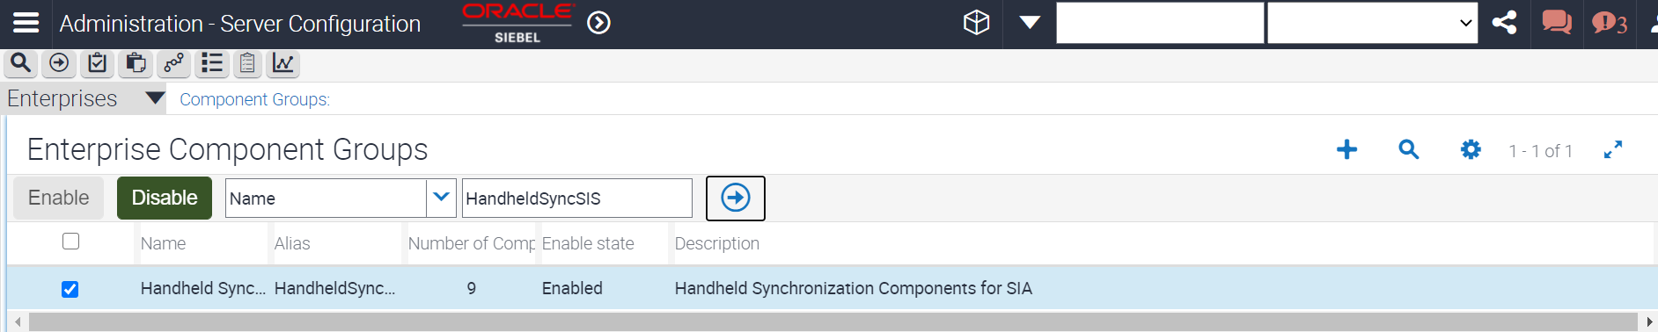

1. Click **Disable** to disable this component group for the enterprise.
2. In the Enterprise Component Groups applet, Query for **Enable state = Disabled.**
3. Verify that **HandheldSyncSIS** is in the list.
4. Verify your changes
5. Navigate to **Site map - Administration - Server Management > Servers > Component Groups.**
6. Select the component group named **Siebel Sales.**
7. Verify its **state.**
8. In the bottom applet, verify that the **Component = Sales Object Manager (ENU)** is now Online
9. Navigate to **Administration - Server Configuration > Enterprises > Component Groups.**
10. In the Component Groups applet, **query for Enable state = Disabled**.
11. In the bottom right (Component Group Assignments) applet, notice that the **Assign, Enable, and Disable buttons are not active.**

**Note:** When a component group is disabled for the enterprise, it is not available to any of the Siebel Servers to run.

Practice 14-2: Set Log Levels, Trace Log Files and Troubleshooting

**Overview**In this practice, you will increase log levels and view the log output from running a job. We will explore Logs, Trace and Explore Logs.

Assumptions

You should have completed the Practice 14-1.

Tasks

1. Set Log Levels
2. Navigate to **Administration - Server Configuration > Servers.**
3. In the Left Side of menu, Select **Component definitions** select **Component = Generate Triggers.**
4. In the bottom (Events) applet, select the record with **Event Type = General.**

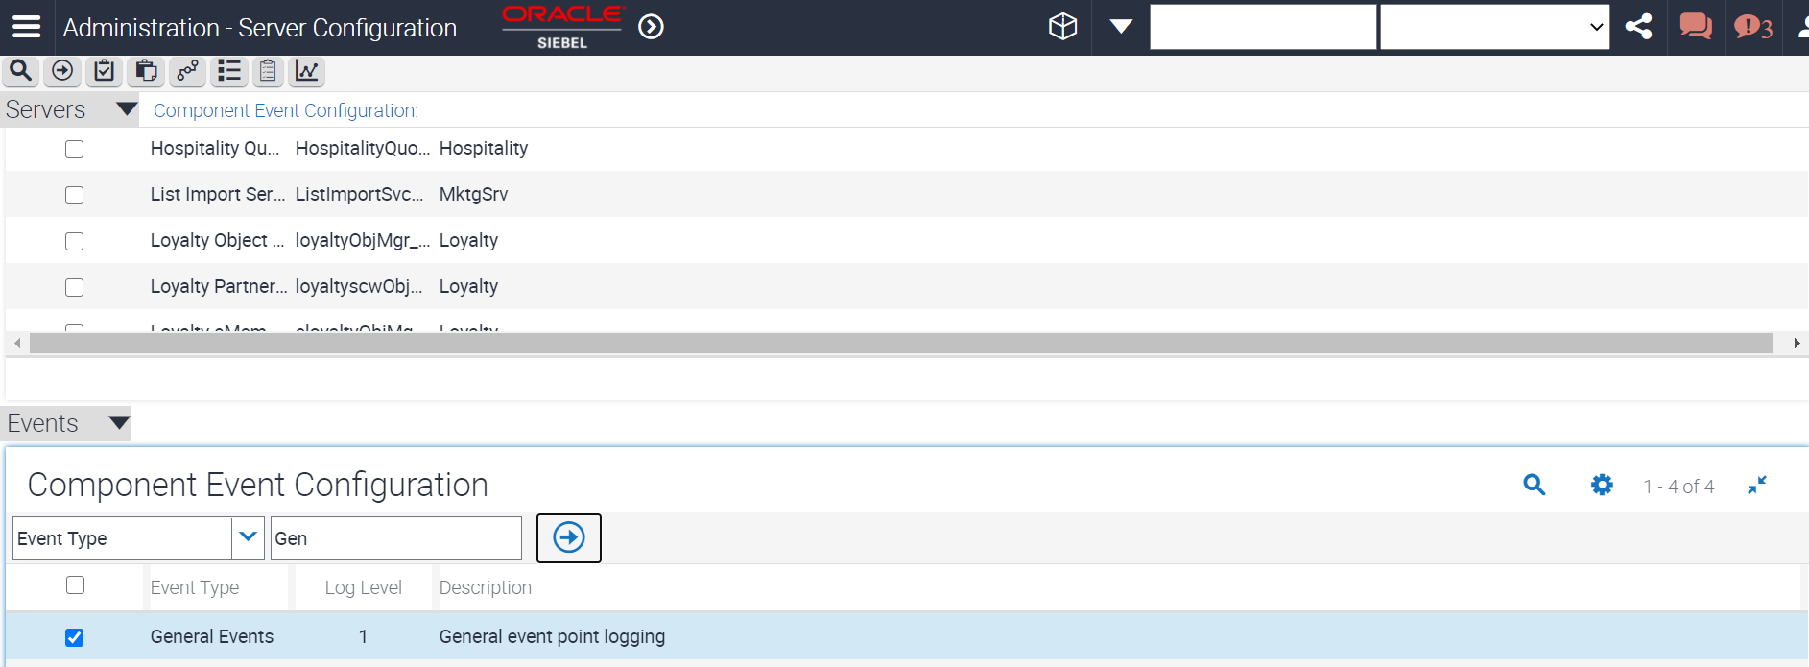

1. Set the **Log Level = 5.** 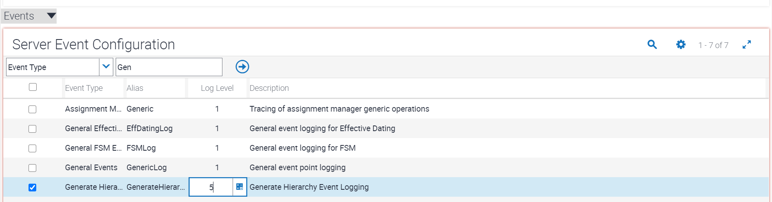
2. Query for **Event Type = SQL Tracing.**
3. Set the **Log Level = 5.**

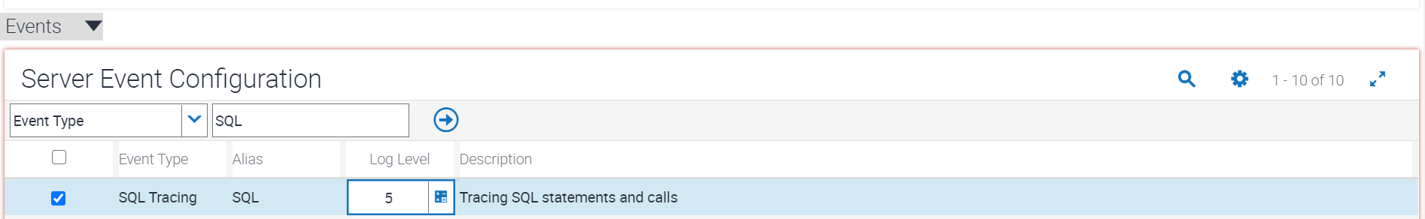

1. **Save** the record.
2. Run a job
3. Navigate to **Administration - Server Management > Jobs.**
4. Select the record with **Component/Job = Generate Triggers and Status = Success**.
5. From the applet-menu, select **Menu > Copy Record.** This is a quick way to run another job with the same parameters as an existing job.
6. Click **Submit Job.**
7. Run **empty queries until the Status = Success.**

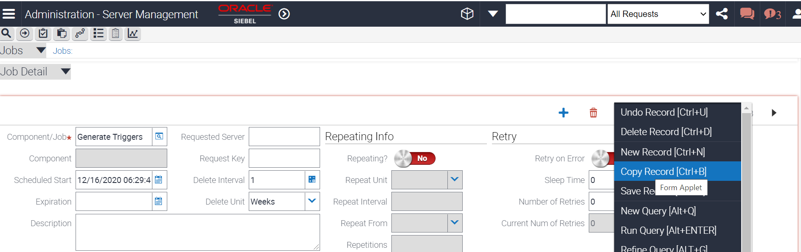

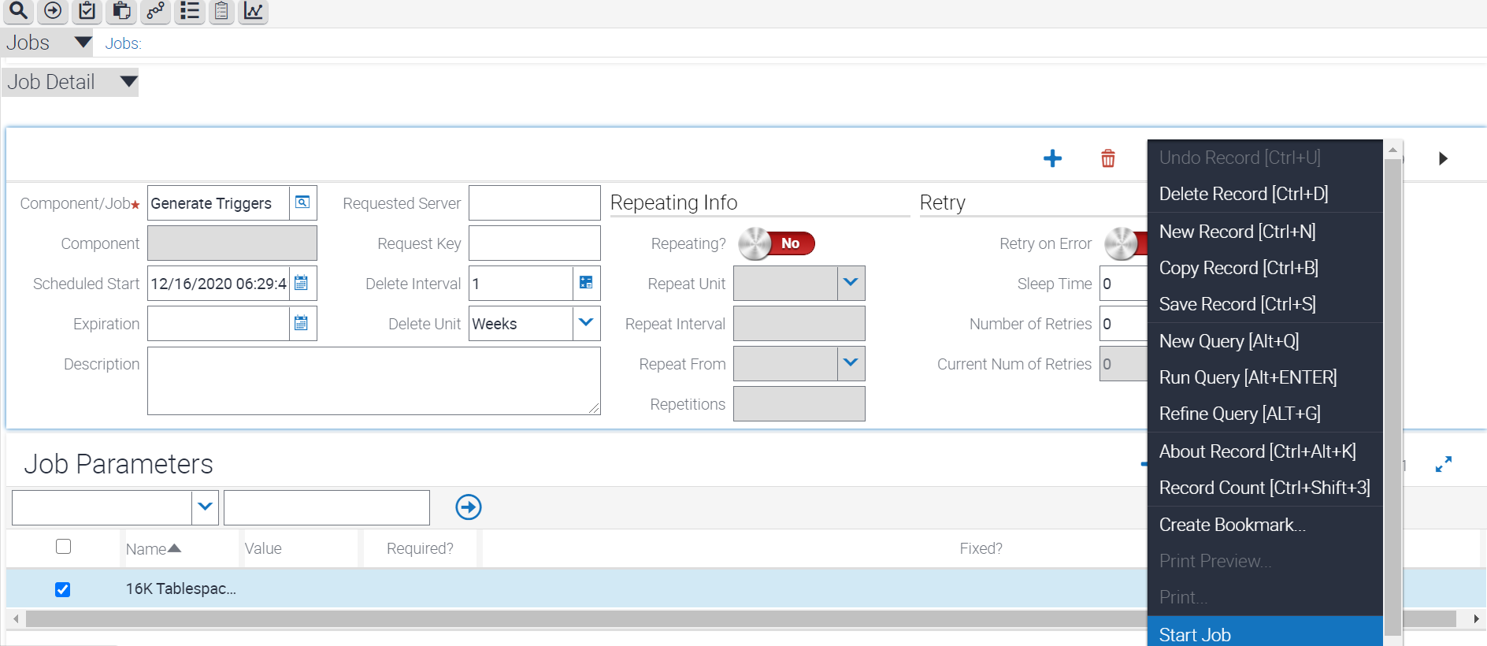

1. Inspect the log in the application
2. In the link bar, click **Tasks.**

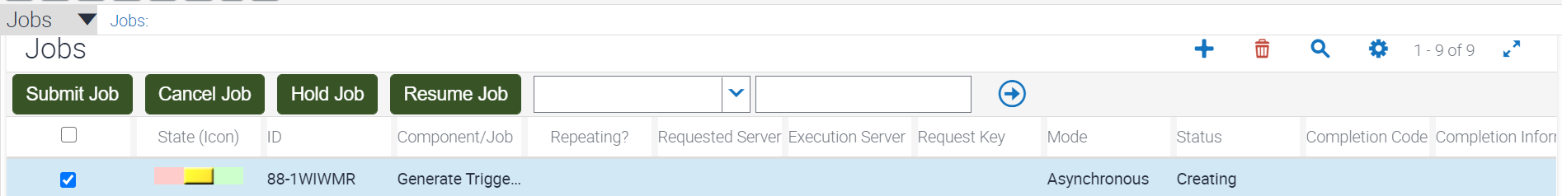

1. Verify that you see a record with **Component = Generate Triggers and Task State = Completed.** It should be the first record.
2. In the bottom (Log) applet, the records will be displayed.
3. In the top (Tasks) applet, note the value in the Task column.
4. Notice that the messages are the same as those listed in the Log applet in the Siebel application.
5. Choose the task submitted or you can submit the task you have created.

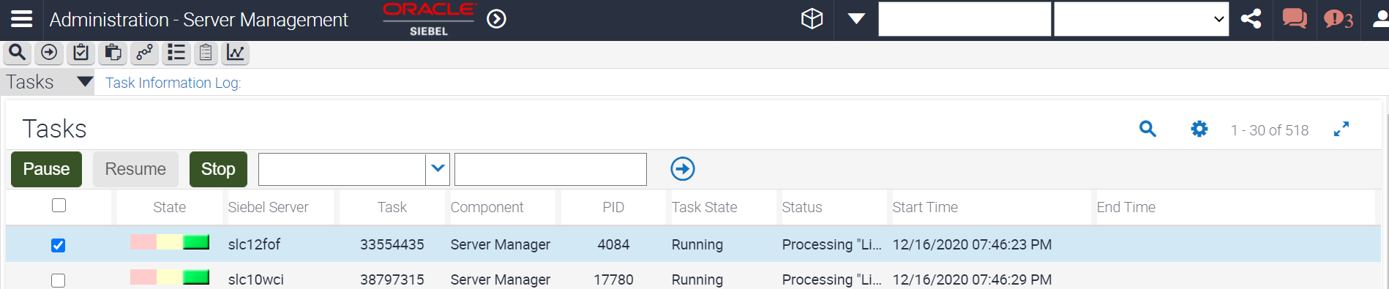

1. Choose the **Log down** below in second menu drop down to get the log details of the task.  
   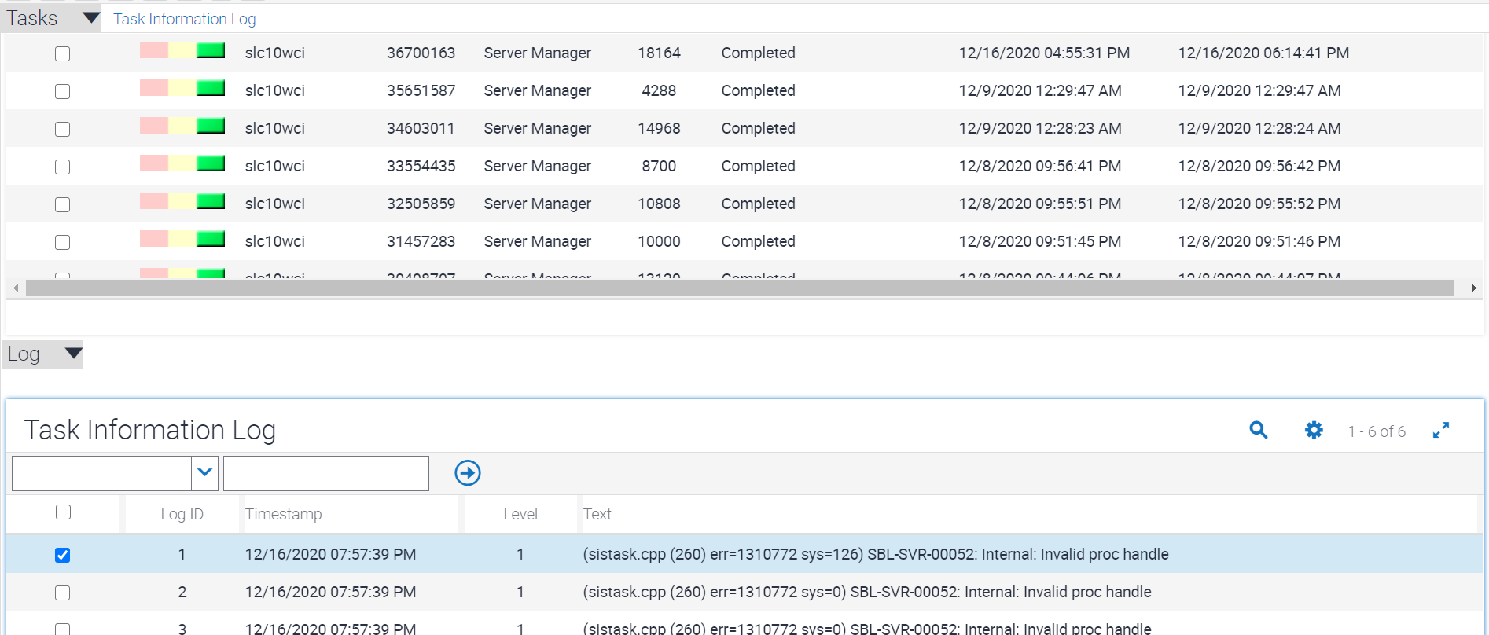
2. Choose **Statistics** from the Log menu to give more information on logs.

